Orca Whale Sound Sort
This package contains spectrograms of nine whale calls. Your job is to identify three whale calls that belong to the same clan. Remember, clan members use similar sounds to communicate.

Answers are provided in red.
Whale Calls From the Same Clan
Spectrogram Three
Spectrogram Five
Spectrogram Seven

Spectrogram One: Off shores
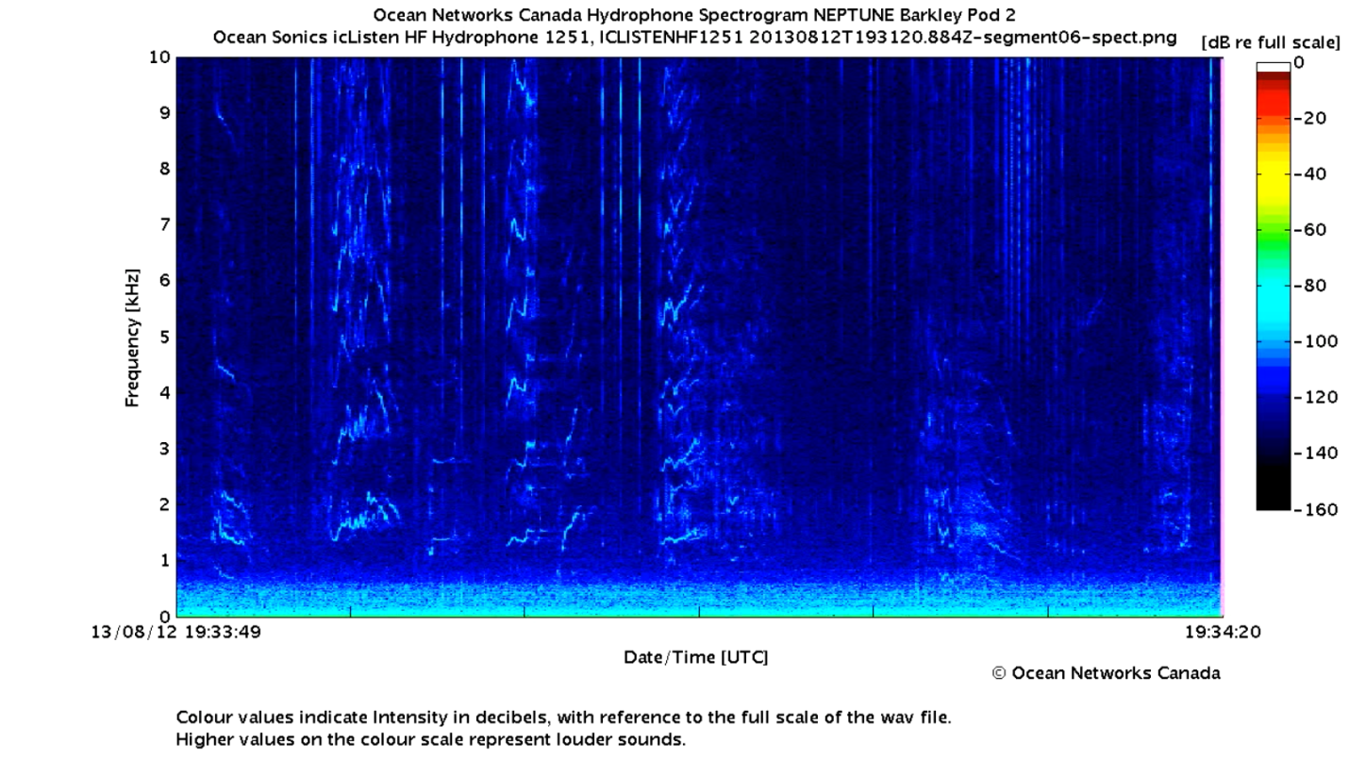

Spectrogram Two: K pod
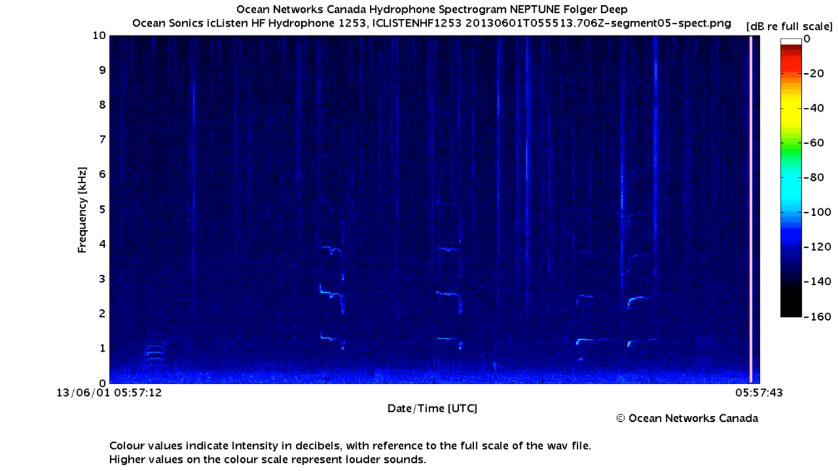

Spectrogram Three: Example 1
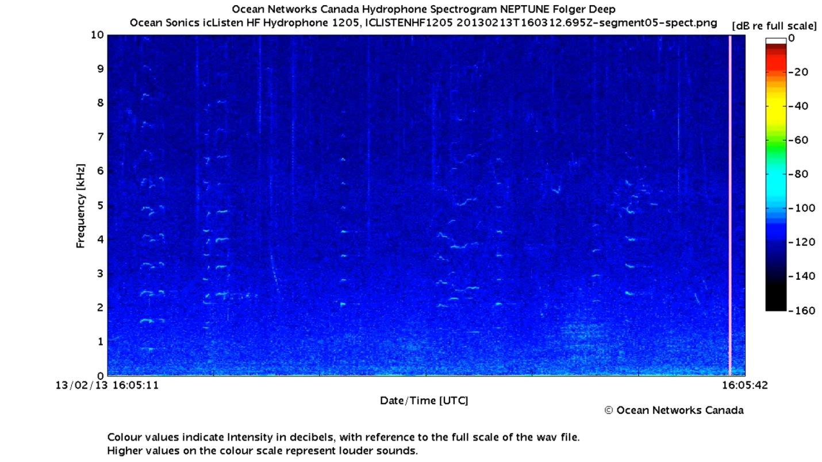

Spectrogram Four: L Pod
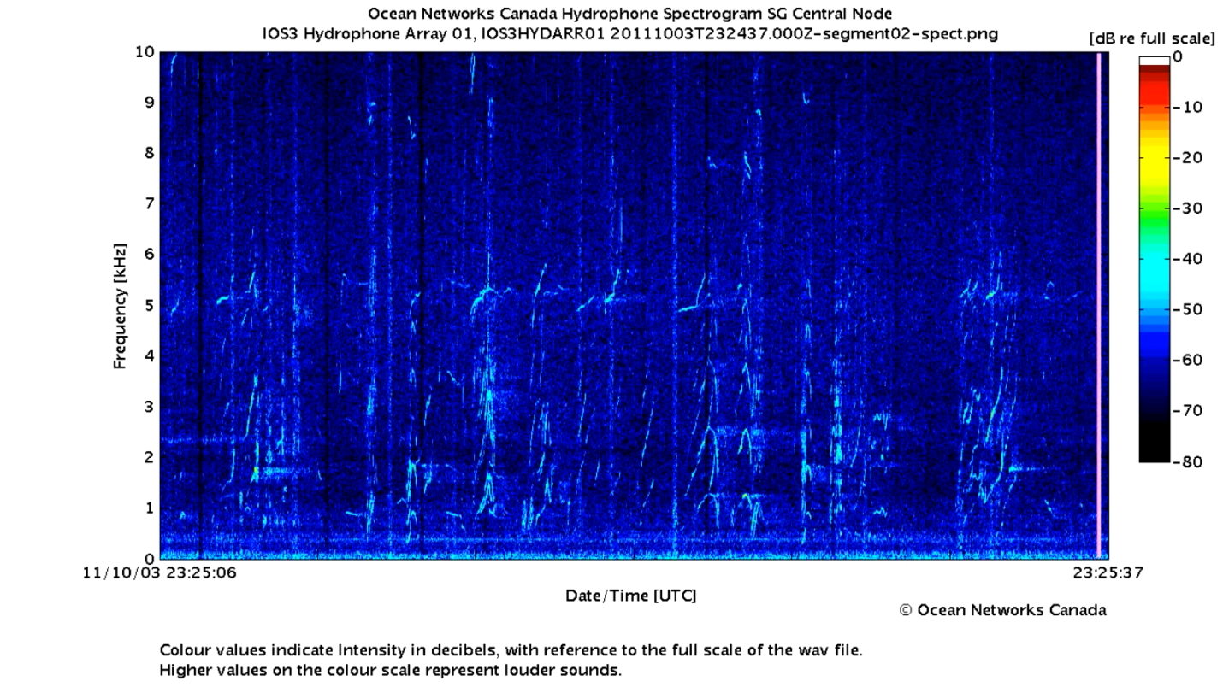

Spectrogram Five: Example 2
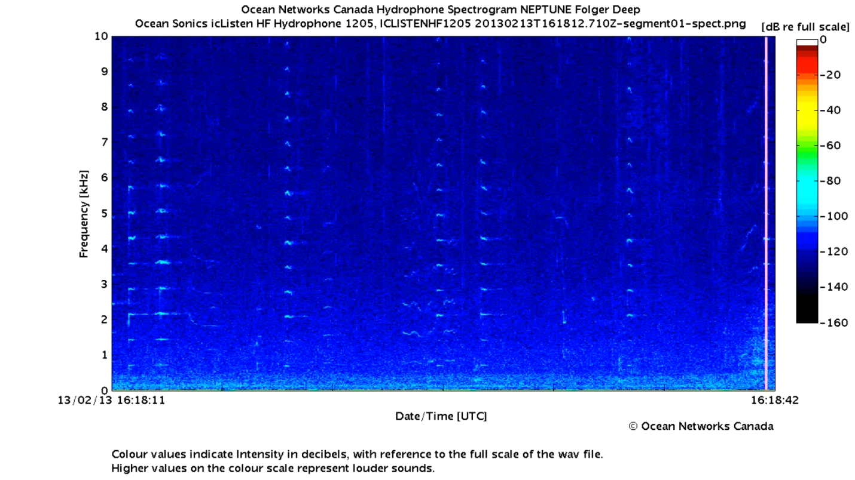

Spectrogram Six: Biggs Killer Whales
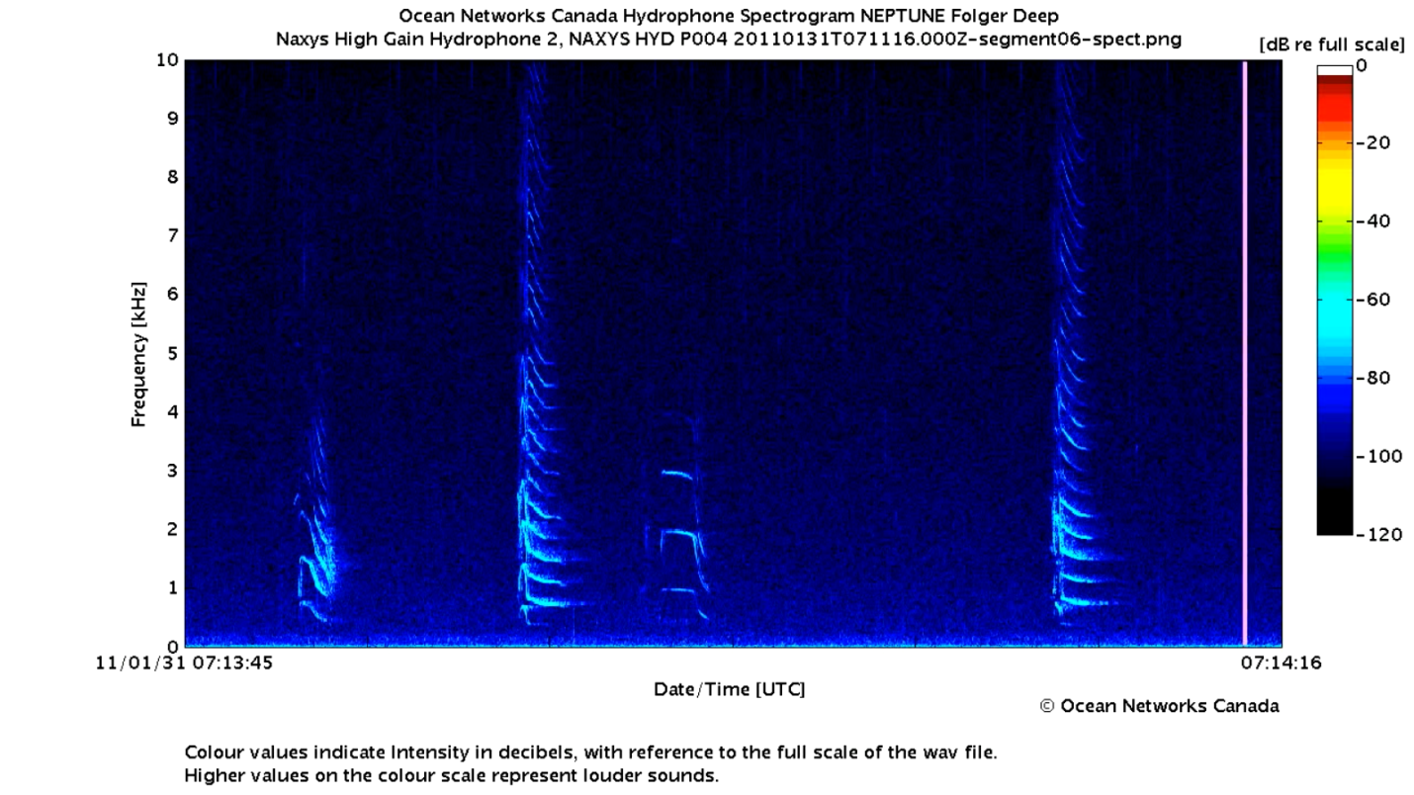
Spectrogram Seven: Example 3
